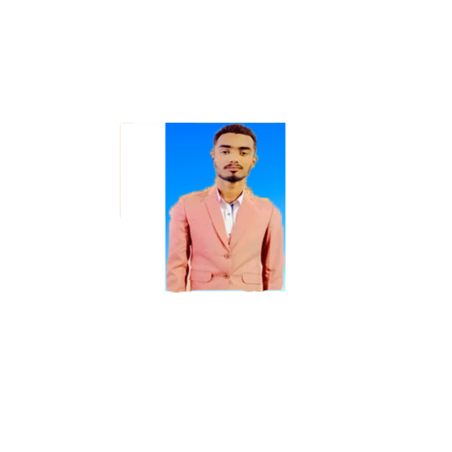**CURRICURUM VITA**

***MUHAMMAD HAMMAD***

House # 736 Sector A, Street # 11 Akhtar Colony.Korongi Road, Karachi. Cell #.0303-2928719

**OBJECTIVE:** I am a Front end developer with a passion for building dynamic and responsive web applications. With a strong foundation in front-end technologies, I aim to create seamless user experiences. My expertise includes HTML, CSS, JavaScript, and frameworks like React. I thrive in collaborative environments, working closely with clients and team members to deliver solutions that not only meet but exceed expectations.

**ACEDEMIC QUALIFICATION:** H.S.C From intermediated board of secondary education Karachi S.S.C Matriculation board of education Islamabad

**JOB RESPONSIBILITIES:** As a Front-End Developer, I built and maintained the parts of websites and web applications that users interact with. I worked with HTML, CSS, and JavaScript to turn design mockups into responsive, user-friendly websites. I collaborated with designers and back-end developers to ensure the website worked smoothly and looked great on all devices. I used frameworks like React or Vue.js to create interactive and dynamic features, and made sure the website loaded quickly and was easy to use.

**PROFESSIONAL EXPERIENCE:** 24-04-2024 Till Experienced in **DIGI TECH ADVERTISERS** {WEB DEVELOPER}

**INTRESTED AND ACTIVITIES:** computer,literature,Music,Information Technology.

**LANGUAGE:** English,Urdu,Sindhi

**COMMUNITY ACTIVITIES:** Working for social organization as a volunteer.

**PERSONAL INFORMATIONL:** Father Name **Nizamuddin** Qualification **Intermediate** C.N.I.C: **42301-6490899-7** Religion: **Islam** Material Status: **Un-Married** Date of Birth: **04-12-2005**